Asparagus - Fresh (Ray)
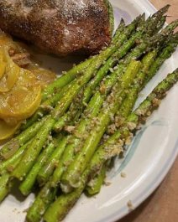
Ingrediencies:
Fresh Asparagus
Olive Oil
Salt & Pepper
Panko Brean Crumps
Parmesan Cheese
Instructions:
Steam Asparagus until tender
(they will not come up when you stick them with a fork)
Drizzle with Olive Oil
Lightly Salt and Pepper
Sprinkle generously with Brean Crumps and Parmesan Cheese
Bon Appétit !

